**MS SQL SERVER**

**Standard Operating Procedures**

**(SOP)**

**Deploying reports for report server**

Submitted to



**By**



CIS, Wipro Limited

Document Details

|  |  |
| --- | --- |
| Project Name | Innogy SE |
| Account | CIS |
| IT Component/Application Title | Configure database reorganization plan |
| Current Version | 1.2 |
| List of Contributors | Pradipkumar Kansara, Kiran Bhalekar, Ayushi Gautam, Sivakumar Goud, Ayushi Srivastava |
| Customer Contact Information |  |

Version History

(All revisions made to this document must be listed in chronological order. All revisions must be approved. Review and Approval can be done by an internal source or by the customer)

|  |  |  |  |  |  |
| --- | --- | --- | --- | --- | --- |
| Version | Date of Revision | Description | Author | Reviewed By | Approved By |
| 1.0 | 10-10-2017 | Initial Draft | Kiran Bhalekar | Pradipkumar Kansara | Santosh Badiger |
| 1.1 | **20-10-2017** | **Document Completed** | **Kiran Bhalekar** | **Pradipkumar Kansara** | **Santosh Badiger** |
| 1.2 | **19-12-2018** | **Updated the content** | **Ayushi Srivastava** | **Pradipkumar Kansara** | **Santosh Badiger** |

Document Distribution List

|  |  |  |
| --- | --- | --- |
| **S.No** | **Name and Company** | **Purpose** |
| **1** | RWEIT-SQLDBA | **This document is about how to deploy report in report server** |
| **2** |  |  |

**TABLE OF CONTENT**

1. Purpose 4

2. Scope 4

3. Steps To Deploy RDL File 4

4. Reference 17

# 

# Purpose

This document to cover how to deploy reports to an instance of SSRS and integration of reports to Application.

# Scope

This document is prepared for GSMC Wipro sustenance team and provides the concepts of deployment and configuration of RDL file in report server

# Steps To Deploy RDL file

**Step 1:**

RDP to the server using service account

**Step 2:**

The report will execute based on schedule time and place the output of file in shared path.

1. Go to Search tab once you login to the server as below:

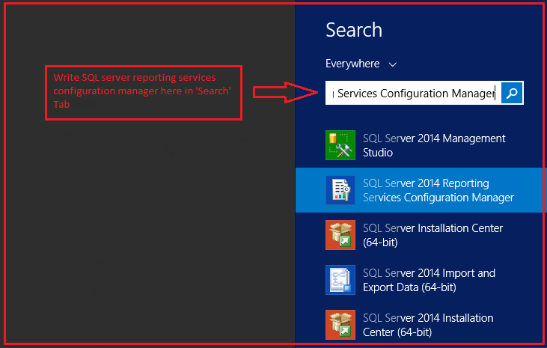

1. You will be able to see below window, once ‘reporting services manager’ will get open. Mention Server and instance name in the below window and then click on connect.

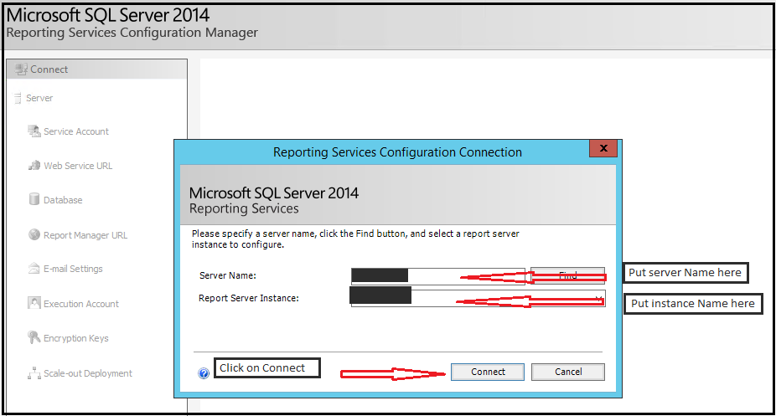

1. After clicking on Connect, you will be able to see below window. Go to Report manager URL and the open the link.

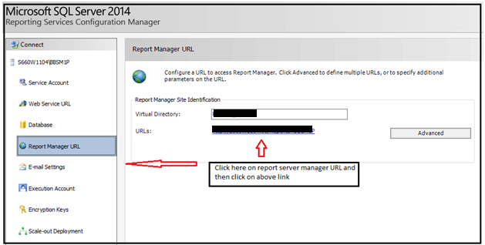

**Step 3:**

Once login to Report Manager, You can able to see two folders, as shown below.

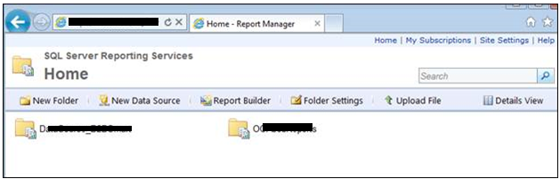

**Step 4:**

Navigate to folder let us consider ‘OOAJobReports’ folder as an example:

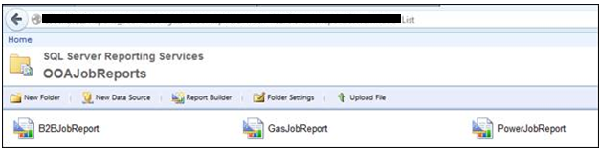

**Step 5:**

Save the RDL file to any local folder

**Step 6:**

Click on upload file option

**Step 7:**

Select the report and click on Open button. Then the report will be uploaded to the Report Manager, Repeat same thing for all the reports

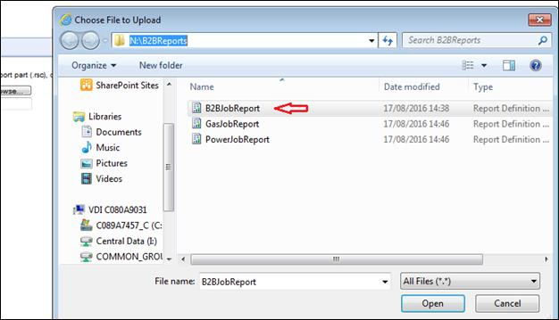

**Step 8:**

The report should is deployed to Report Manager successfully as shown below.

